Payroll Management System for Information Technology Company

Use-Case Specification: Update Project

Version 1.0

Revision History

|  |  |  |  |
| --- | --- | --- | --- |
| **Date** | **Version** | **Description** | **Author** |
| 16/12/2019 | 1.0 | Final | Quản Trọng Tú |
|  |  |  |  |
|  |  |  |  |
|  |  |  |  |

Table of Contents

1. Use-Case Name 4

1.1 Brief Description 4

1.2 Actor 4

2. Flow of Events 4

2.1 Basic Flow 4

3. Special Requirements 5

4. Preconditions 5

5. Postconditions 5

6. Extension Points 5

Use-Case Specification: Updating Project

# Use-Case Name

## Brief Description

This use case defines the steps of updating a project to store it in the database system. Administrator can easily update a exist project.

## Actor

Administrator

# Flow of Events

## Basic Flow

The system Administrator type the project id and click search to find out the specific project. After that, the administrator clicks update button to create update form and view all information of this project. The system admin clicks submit to update project to database and continue doing other functions.

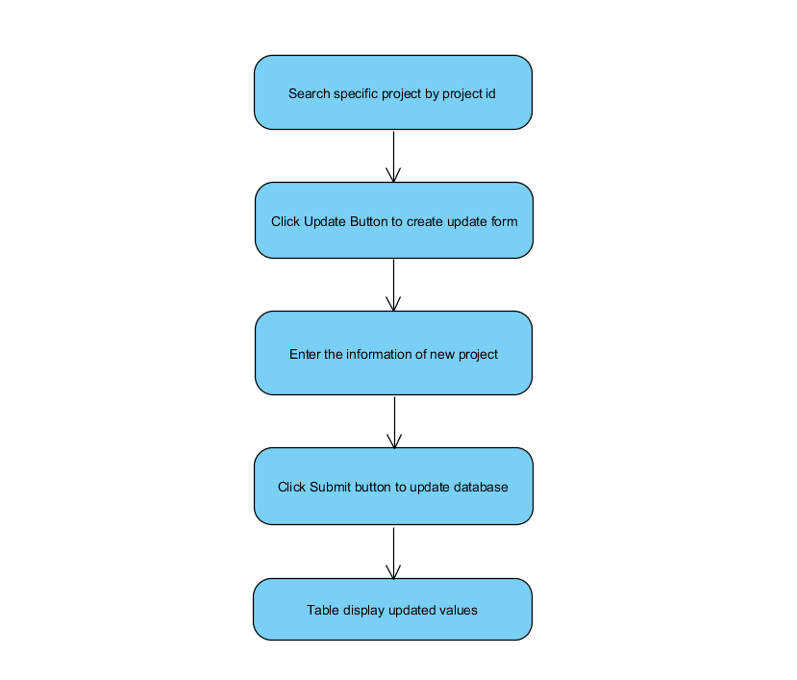

Basic Flow of Adding Working Time

# Special Requirements

* Administrator need to input correctly.
* Search project success.

# Preconditions

* Administrator have to login into application and access Manage project view.

# Postconditions

* Application shows message.
* Project’s total earning changed, salary of all user in this project changed automatically.

# Extension Points

Check project information by search specific project.